Finger Tracking using Magnetometers

Alexander Mastrangelo and Paul Yoo, University of Washington

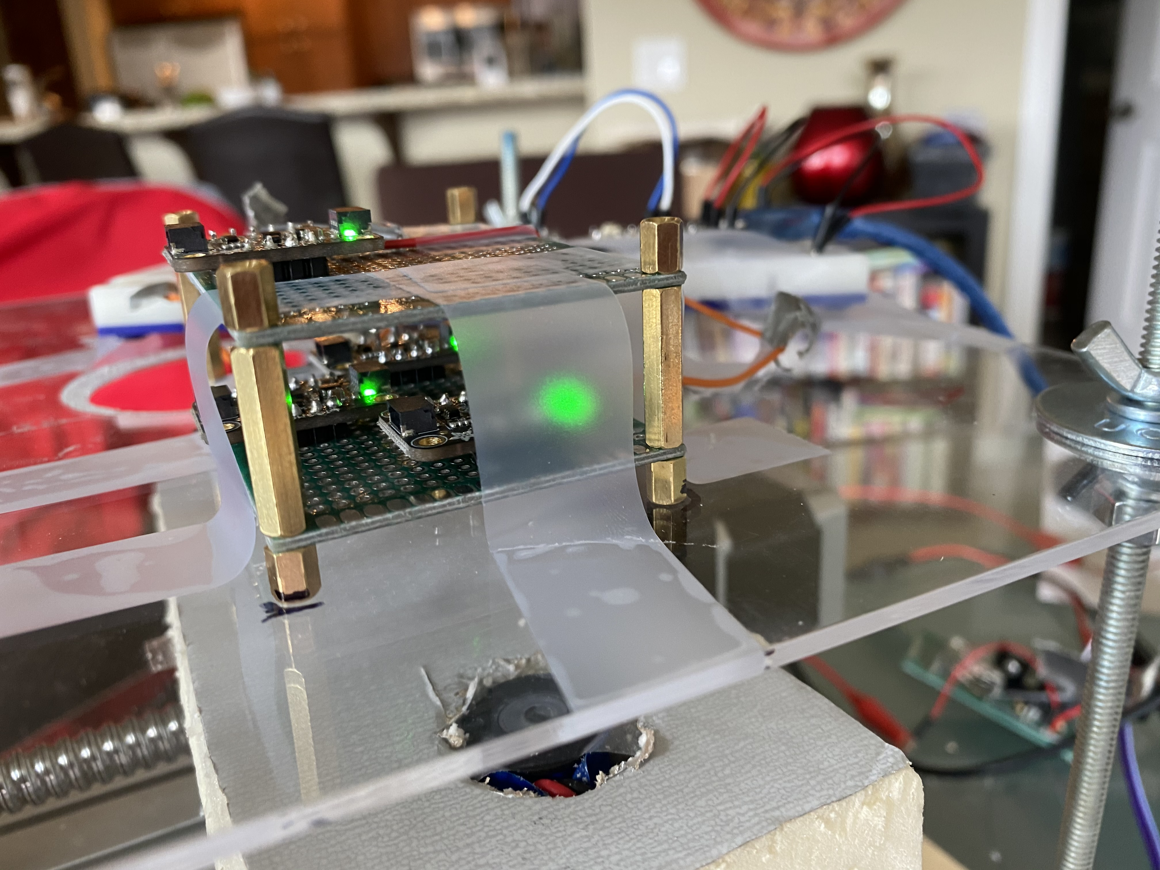

Figure 1: The finger tracker mounted to an XY table for taking measurements.

ABSTRACT

We used 4 magnetometers to track the position of an electromagnet driven with alternating current.

 Introduction

The purpose of this project is to build a high-accuracy finger tracking for use in VR. We believe good finger tracking is important because it allows players to interact with VR environments without the needing a controller. Although there are many approaches for tracking position, magnetic tracking is a good solution for tracking fingers because they suffer from occlusion. This means that other approaches for tracking position such as lighthouse and marker-based tracking are not good for solving this problem.

The layout of the magnetometers is based on that of the Finexus design by Oculus. As for the electromagnet, it is surprisingly difficult to get an electromagnet that can be mounted to a finger, so we had to build our own out of a solenoid and dolly pins.

1.1 Contributions

1. Built a magnetic finger tracker

2. Implemented a model to solve the position of each finger

3. Measured accuracy of the model using an XY-table

2 Related Work

This project is basically a reimplementation of the Finexus project, except with less time, less budget and less experience. As such its very much a subset of their work [FINEXUS]. That said the implementation details of the hardware are very different.

3 Method

To implement the tracking, we mounted 4 magnetometers to perfboards, as shown in figure 1. These magnetometers are driven through the i2c bus by a Teensy 4.0 Arduino. Given that the magnetometers share the same i2c bus, an i2c multiplexer is used to enable/disable magnetometers.

Using these magnetometers, we measure the magnetic field of an electromagnet that is driven by alternating current. The purpose of this is to extract the signal of the electromagnet from the Earth’s magnetic field, and other magnetic noise. It can also be used to track multiple electromagnets driven at different frequencies [1], but that is not implemented in this paper.

Once we have the waveforms of the magnetic field measured, we run these through the Fourier transform to extract the amplitude of the electromagnets’ field.

4 Implementation Details

To make it work we had to mount the magnetometers at known positions relative to each other. This was done very carefully as any uncertainty here will break the model. Thankfully the perfboard matched this requirement exactly, as we can just place them at a fixed offset relative to each other. This only works for 3 of the 4 magnetometers required, because the last one is on a different plane than the first 3. In our implementation we chose 8 holes to be the distance between sensors, which is exactly 20.3mm.

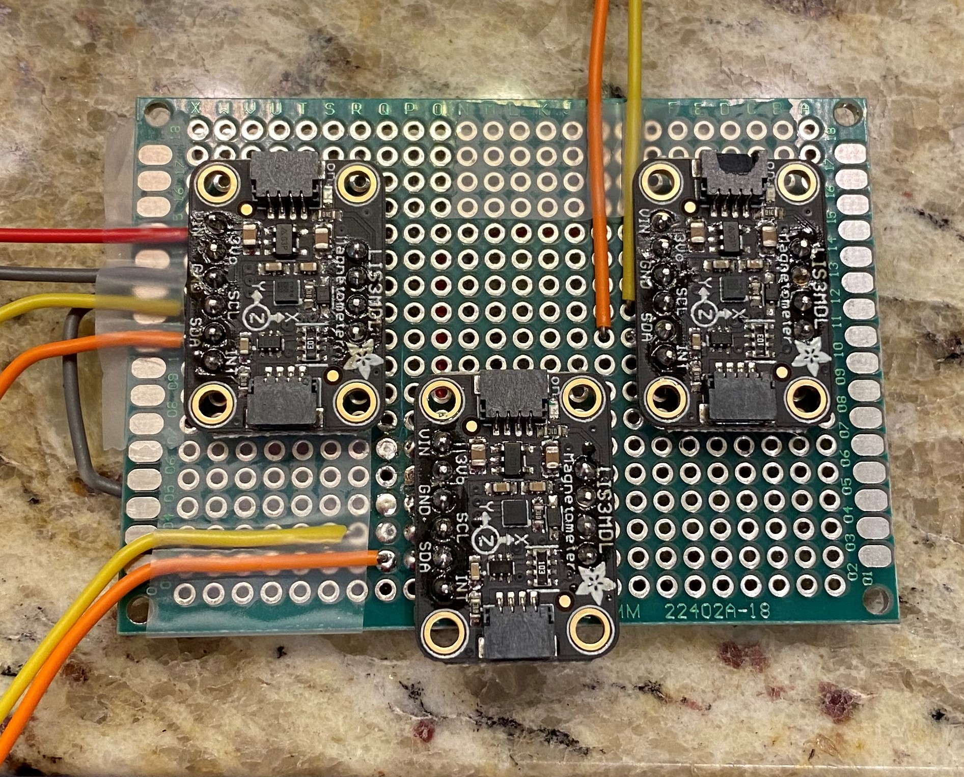

Figure X: The magnetometers mounted to the perf board

The perf board used had mounting holes on the sides, which were used to connect the top and bottom boards. It’s important to note that the wires and spacers used were nonmagnetic, as to avoid introducing any soft iron effects into the system. [4]

With this, all four magnetometers were mounted similar to the Finexus configuration [1], with coordinates of (0,0,0), (20.3, 20.3,0), (20.3,-20.3,0), and (0,0,21.6). The power and voltage pins of each chip were shorted, and the i2c pins were routed out the sides.

Communication with the magnetometers was done over the i2c bus. Since all the magnetometers shared the same i2c bus, we used a TCA9548A to split the i2c bus; allowing us to talk to all the sensors, even though they all share the same address.

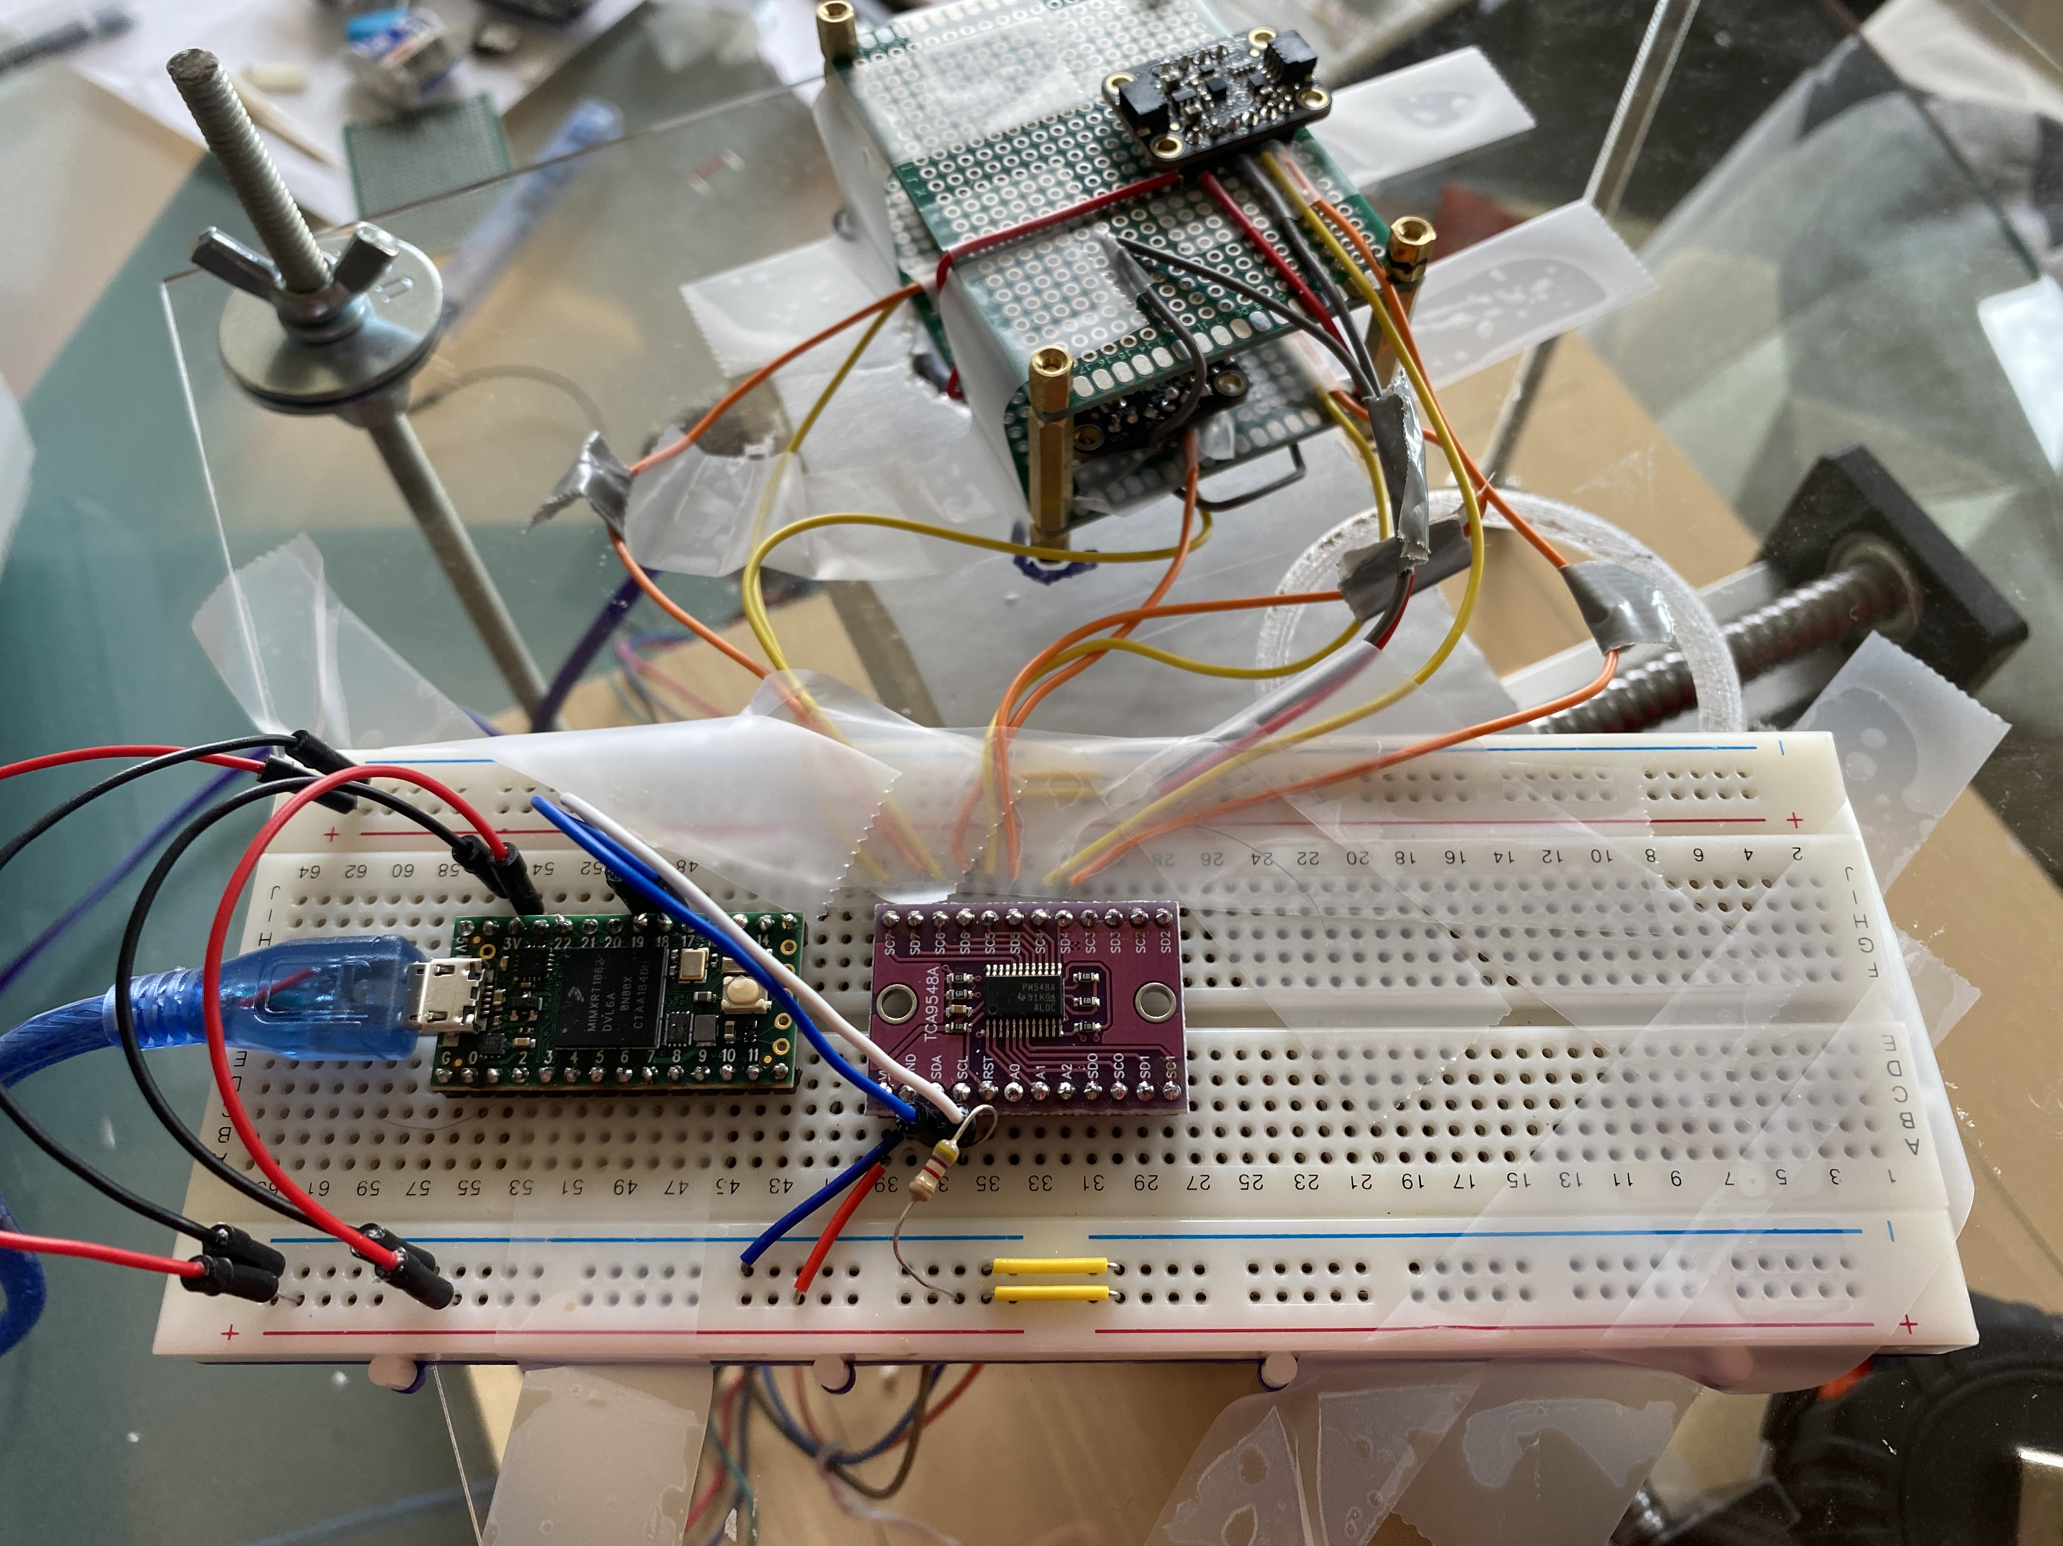

The calibration procedure is simple, we rotate the sensor in random directions, while keeping them away from anything magnet. We used MotionCal by PJRC to solve for the calibration matrix and biases for each sensor.

To drive the electromagnet, we built a voltage controlled current source. It uses a rail to rail LM358 op amp, and a TIP31 power BJT to push a current through the magnet defined by a signal generator.

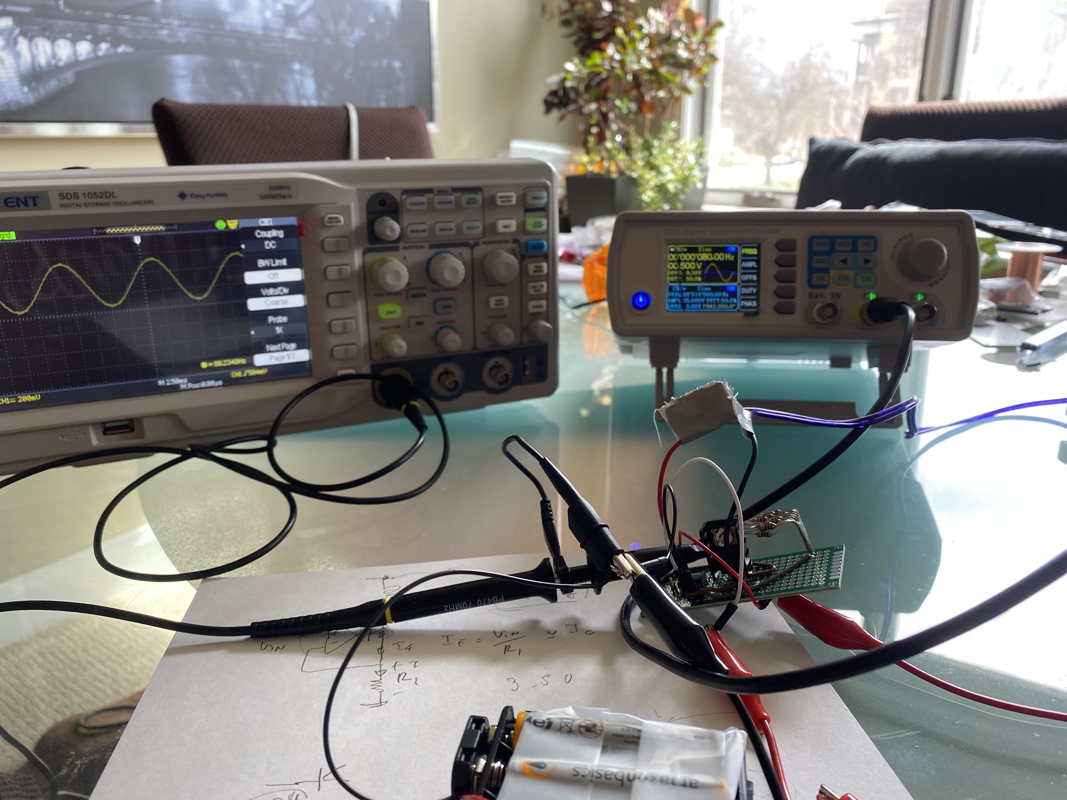

Figure X: The signal generator providing the sin waveform to the amplifier, and the oscilloscope measuring the current through the electromagnet.

Acquiring an electromagnet small enough for this purpose was surprisingly difficult. The only stuff I could find on amazon was solenoids, so to get the magnet we ripped a solenoid apart to get the coil, and then used an iron dolly pin as the core of the electromagnet.

Finally, to drive the electromagnet we first used a signal generator to make a 60hz sin wave. This sin wave was then fed into the following amplifier circuit to control the current though the electromagnet.

4.1 Solving for 3D position

We use a modified system of equations from the Finexus tracking system to solve for the position of the electromagnet [1].

The first thing we do is acquire 1000 samples of measured data for each magnetometer.

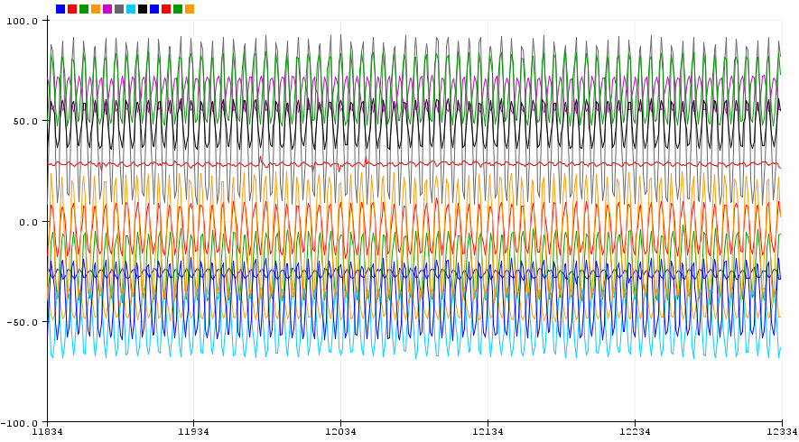

**Figure X:** All 12 components of the magnetometers when near an electromagnet oscillating at 80hz.

Each of the xyz components of the magnetometer measurements are put through the Fourier transform, to obtain the amplitude of the field induced by the electromagnet for each sensor.

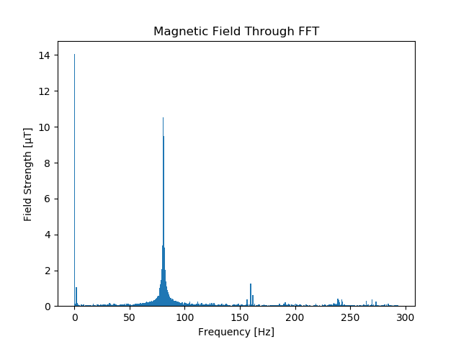

Figure X: FFT applied to a single component of the magnetometers. Notice the peaks at 0hz and 80hz.

Now we have the magnitude of the magnetic field at each sensor. resulting from the electromagnet

Once we obtain **H** = [Hx, Hy, Hz]T which represents the strength of the magnetic field in the x, y, and z directions, we now have to solve for ||**H**||2 = K * r -6 *(3cos 2 θ + 1) which is the equation for the total magnetic field strength. The variable r here is the distance from the magnetic field and θ is the tilt angle between the sensor and the magnetometer and K is a constant. However, since this is an under-constraint system with two unknowns and one equation, we need to introduce more equations. We can do this by rewriting r, and θ in terms of the magnetometer’s 3D position x, y, z. Since we know the relative positions of the four magnets we can get the following equations:

**r1** = [x2 + y2 + z2]1/2

**cos θ1** = z / r1

**r2** = [(x – 20.3)2 + y2 + z2]1/2

**cos θ2** = z / r2

**r3** = [x2 + (y – 20.3)2 + z2]1/2

**cos θ3** = z / r3

**r4** = [x2 + y2 + (z – 21.6)2]1/2

**cos θ4** = z / r4

Now if we substitute each pair of equations back into

||**H**||2 = K * r -6 *(3cos 2 θ + 1) we can get the following over-constraint system:

||**H0**|| = K * [x2 + y2 + z2]-3/2 *(3z/ [x2 + y2 + z2]1/2)

||**H1**|| = K * [(x-20.3)2 + y2 + z2]-3/2 *(3z/ [(x-20.3)2 + y2 + z2] 1/2)

||**H2**|| = K * [x2 + (y-20.3)2 + z2]-3/2 *(3z/ [x2 + (y-20.3)2 + z2] 1/2)

||**H3**|| = K * [x2 + y2 + (z-21.6)2]-3/2 *(3z/ [x2 + y2 + (z-21.6)]1/2)

And we minimize the error function.

$$ϵ=\sum_{i=0}^{3}{{(\left\|H_{i}\right\|-\left\|M_{i}\right\|)}^{2}}$$

Where $M_{i}$ is the measured value for the magnetic field for each sensor, and $H_{i}$ is the theoretical value. We now have an overdetermined system of nonlinear equations which can be minimized with the scipy.optimize.minimize Broyden algorithm, which does not require the Jacobian computation [5].

5 Evaluation of Results

To evaluate the accuracy of the finger tracker, we required a way to know the exact position of the electromagnet. To do this we acquired data with an XY table. The electromagnet was mounted to the moving part of the table, and the tracker was mounted above on a sheet of plastic.

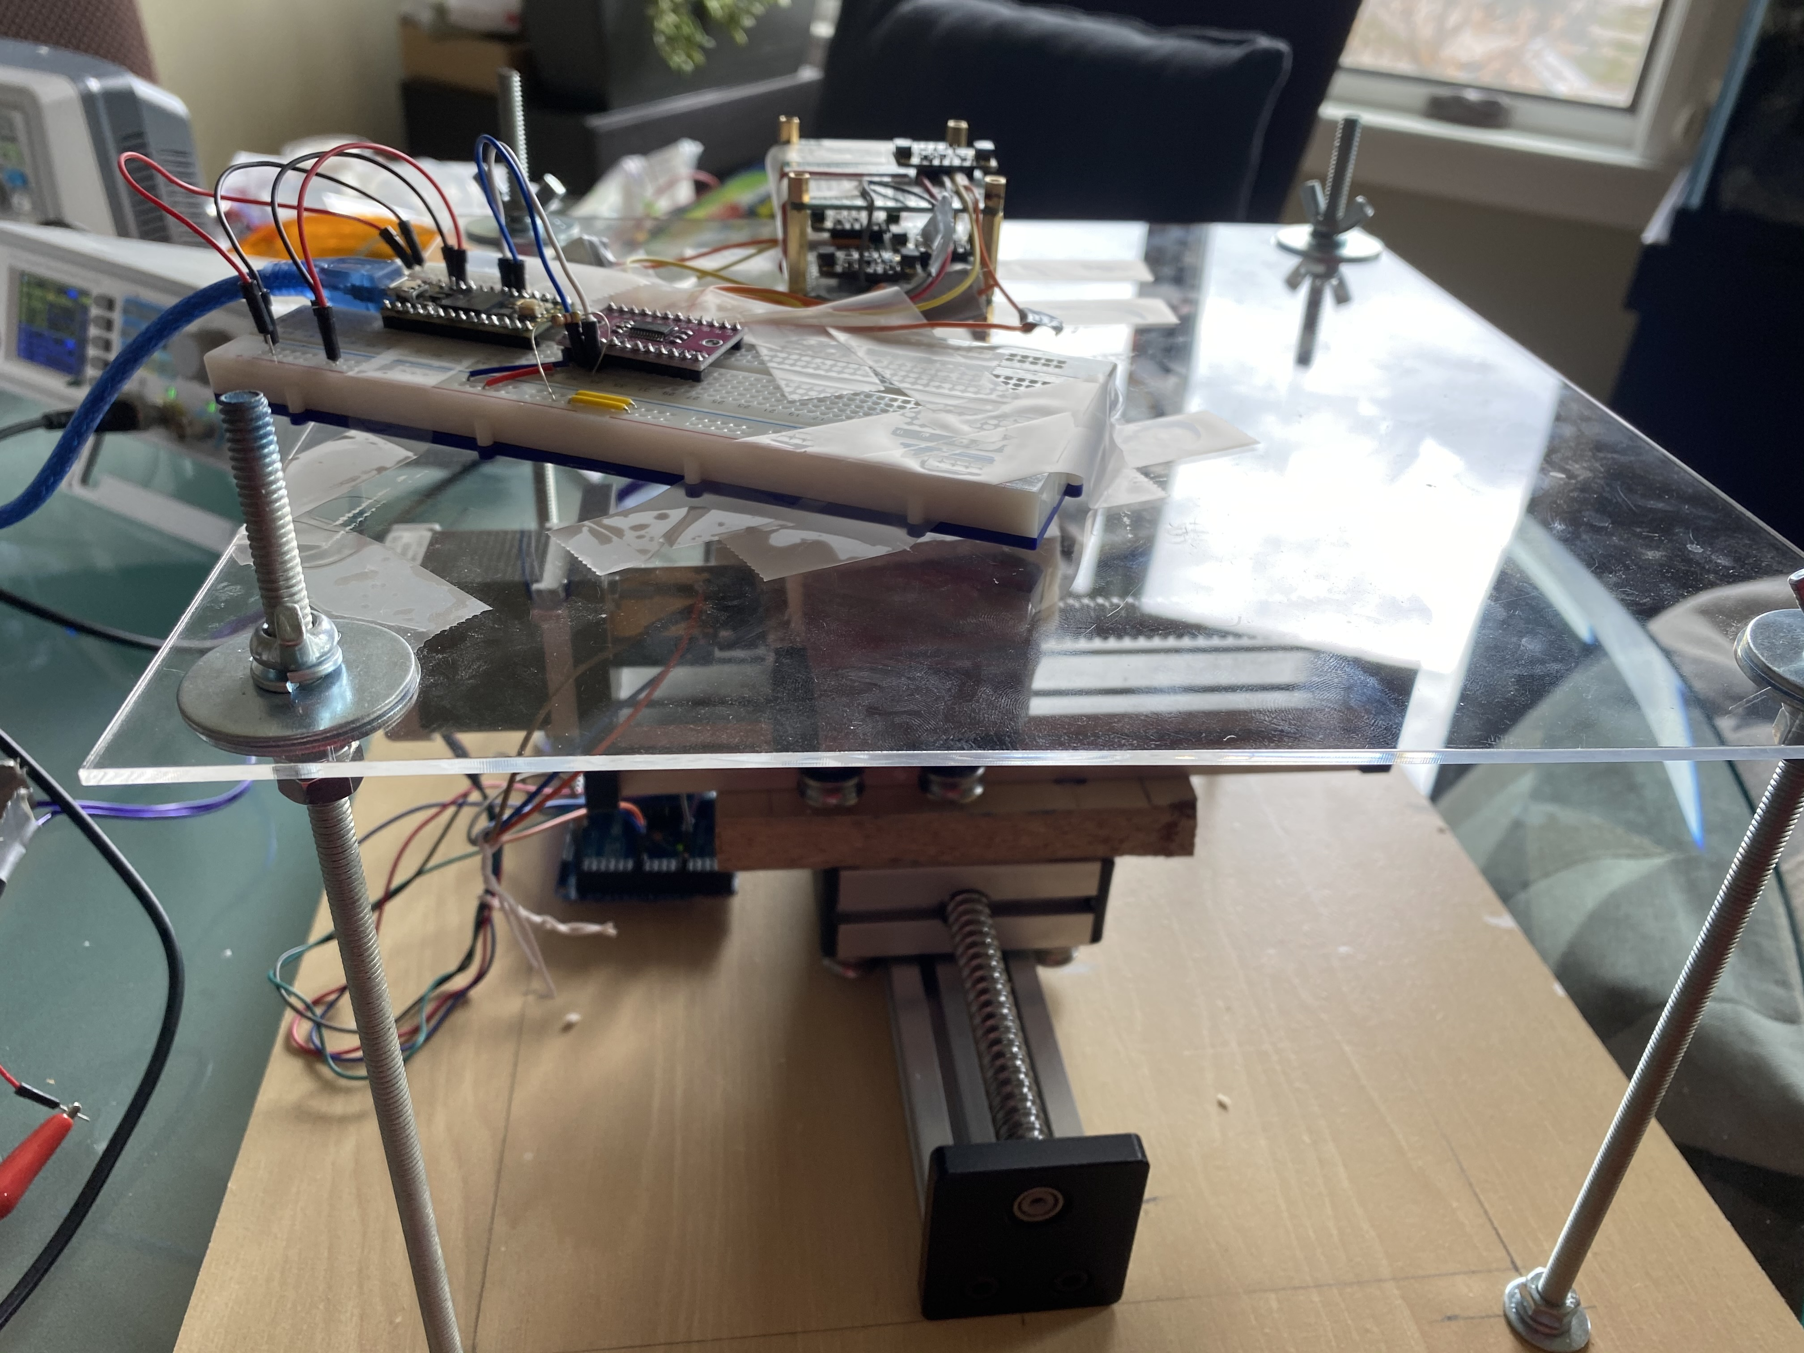

Figure X: Experimental setup for getting data using an XY table

We then used scipy non-linear optimization to solve the equations described in section 4, giving us an estimated position. This data was recorded with the electromagnet 50mm below the tracker.

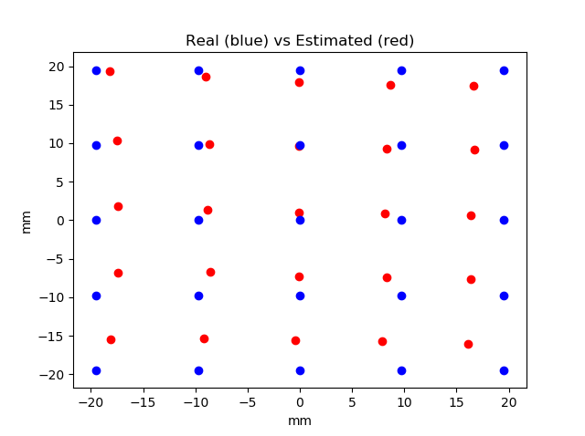 **Figure X:** The predicted vs actual position of the electromagnet

The accuracy is pretty good, with mean distance error of 10.59mm and standard deviation of 21.59mm.

6 Discussion of Benefits and Limitations

The biggest limitation of this approach is that it is susceptible to magnet interference. Even putting a non-magnetized piece of iron too close to the tracker negatively affects the accuracy of the measurements. [4]

Another limitation is the calibration of the magnetometers. This calibration can change based on temperature or if a strong enough magnetic field is applied to the sensor [SOURCE]. Therefore, the tracker must be recalibrated often, otherwise the sensors will give bad data.

The biggest benefits of magnetic tracking are that it does not suffer from occlusion, which is especially beneficial when it comes to tracking fingers. Another benefit is that it can be made extremely accurate, with sub milli-meter accuracy if done well. [SOURCE]

7 Future Work

The next step for this work would be to combine it with a solution to track the 6-DOF of the hand; as well as to mount the magnetometer tracker and electromagnets to a glove that can be worn. Two viable solutions for the 6-DOF are marker-based tracking, and lighthouse-based tracking.

Another next step would be to acquire faster magnetometers. The biggest weakness of this approach is that the cheap commercial magnetometers IC’s on the market run at only 1khz. Faster magnetometers would enable us to tracking electromagnets running at higher frequencies. This is important because as we increase the frequency of the electromagnet, we decrease the uncertainty of the measurement, greatly improving accuracy. [SOURCE?]

8 Conclusion

Basically just redo the abstract.

ACKNOWLEDGMENTS

Special thanks to my dad for buying all the parts we needed.

REFERENCES

[1] Chen, Ke-Yu & Patel, Shwetak & Keller, Sean. (2016). *Finexus: Tracking Precise Motions of Multiple Fingertips Using Magnetic Sensing.* 1504-1514. 10.1145/2858036.2858125.

[2] https://makersportal.com/blog/2018/2/25/python-datalogger-reading-the-serial-output-from-arduino-to-analyze-data-using-pyserial

[3] https://learn.adafruit.com/adafruit-sensorlab-magnetometer-calibration

[4] https://diydrones.com/profiles/blogs/advanced-hard-and-soft-iron-magnetometer-calibration-for-dummies

[5] Juan Nunez-Iglesias, Stéfan van der Walt, and Harriet Dashnow. *Elegant SciPy: Elegant SciPy: The Art of Scientific Python*, O'Reilly Media; 1 edition (August 31, 2017)

Conference Name:ACM Woodstock conference

[6] https://www.ritchievink.com/blog/2017/04/23/understanding-the-fourier-transform-by-example/

Conference Short Name:WOODSTOCK’18

Conference Location:El Paso, Texas USA

ISBN:978-1-4503-0000-0/18/06

Year:2018

Date:June

Copyright Year:2018

Copyright Statement:rightsretained

DOI:10.1145/1234567890

RRH: F. Surname et al.

Price:$15.00

[7] Sten Andler. 1979. Predicate path expressions. In *Proceedings of the 6th. ACM SIGACT-SIGPLAN Symposium on Principles of Programming Languages (POPL '79)*. ACM Press, New York, NY, 226-236. DOI:https://doi.org/10.1145/567752.567774